MATHEMATICS SCHEME OF WORK FOR PRIMARY SIX TERM I, 2024

|  |  |  |  |  |  |  |  |  |  |  |  |  |  |  |
| --- | --- | --- | --- | --- | --- | --- | --- | --- | --- | --- | --- | --- | --- | --- |
|  | W  K | PD | TOPIC | SUB-TOPIC | | CONTENT | COMPETENCES | | METHODS/ TECHNIQUES | T/AIDS | LIFE  SKILLS&  VALUES | T/L ACTS | RE  FE  RE  NC  E | R  E  M  A  R K  S |
| LANGUAGE | SUBJECT |  |
|  |  | 11a nd2  2 | SE  T  S | TYPES SETS | OF | Equal sets - Have same type and number of members.  Example   1. = {2 , 3, 4, 5} 2. = {3 , 2, 5, 4}   Sets A and B are equal sets.  Equivalent sets – Have same number of element but may be of different type examples. A = {1, 2,  3, 4, 5}  B = {a , b, c, d,e}  Sets A and B are equivalent.  Intersection Set (U)  A set of members common to two or more given sets.  Example :   1. = {0,2,4,6} 2. = {1,2,3,5}   Set AnB = {2}  Union Set (U) – A set of all elements contained in given sets. | A learner reads the words such as equal , equivalent intersection  and union connects.    Constructs oral  sentences  using the words above. | A learner   * Counts elements in given sets. * Forms new sets | Question and  answer      Discussion    Explanation | Charts          Chalkbo ard illustrati  on      Plastic bottles | Critical thing Analitical thinking Confiden ce | A learner       * Forms sets * Identifies sets | A ne  w MK  MT  C bK 6  Pg  1 -  5 |  |
| 23 | TYPES OF  SETS | | Universal sets ( ∑)  Is the biggest set from which other small sets can be obtained.  Example :  A B     1. 1 4 2. 2   3  7  Find (i) ∑= 1,2,3,4,5,6,7}  (ii) A = {1,2,3,5,6}  (iii)B=(1,2,3,4) iv) AnB={1,2,3}  v) AᴜB= {1,2,3,4,5,6} | A learner   * Scribes a universal set. * Identifies members   of the  universal set | A learner   * Reads the word universal * Uses the word universal in sentences. | Explanation    Chalk board illustrations.    Question and answer | Chart        Chalkbo ard illustrati on | Problem solving Critical thing fluenc | A learner    Draw venn diagram | A ne w MK  MT  C  BK  6  Pg  4 –  5 |  |

|  |  |  |  |  |  |  |  |  |  |  |  |  |  |
| --- | --- | --- | --- | --- | --- | --- | --- | --- | --- | --- | --- | --- | --- |
|  | 3 | 4 |  |  | A learner  - Describes complem  ent of  sets | A learner - Reads | the |  |  |  | A learner    - Draws venn diagram | -do-    Pg  4 – 7 |  |
| 4      55 | A ne  w MK  MT  C  pu  pils  BK  6  Pg  8 -  10 |  |
|  | 66 | Shading and  describing shaded regions | Shading and describing shaded regions  A B C D        P Q | A learner   * Identifies shaded parts. * Shades required regions of sets. | A learner -describes shaded region  -reads questions confidence | the the | Chalk board  illustrations    Discussion      Explanation Question and answer | A chart      Chalk board  illustrati ons. | Problem solving Critical thinking confiden ce | A learner  -Draw venn diagram -Shades required regions -Identifies shaded  regions | -do-  Pg  59  -  60 |  |

|  |  |  |  |  |  |  |  |  |  |  |  |  |
| --- | --- | --- | --- | --- | --- | --- | --- | --- | --- | --- | --- | --- |
|  | 61 |  | Interpreting elements terms numbers | in of | A LEARNER  - Describes informatio  n.  venn  diagram.    Find ∑ = 30        N(M) = 20 n(F) = 15        20    –    x x 15  –    x      2 | A LEARNER   * Draws venn diagrams * Represents diagrams * Represents information * Solve equations | * Discussion * Explanation * Discovery methods | - Chalk board  illustra tions | Problem solving Creative thinking Apprecia tion | Drawing venn Diagram Adding numbers | A ne w MK Pri  ma  ry  MT  C  20  00  BK  6  Pg  29 |  |
|  | 72 | Showing  number of elements on a venn diagram | | Problem solving Critical thinking confiden ce | Drawing venn diagram      Adding  numbers    Subtracting numbers | Mk bk  pg 29 |  |
|  | 83 | Word problem in venn diagrams.  With simple  probability | | Critical thinking Problem solving Effective  commun  ication | Drawing venn  diagram        Reading and interpreting Information | A ne  w MK  Pri  ma  ry  MT  C  20  00  (ol d edi |  |

|  |  |  |  |  |  |  |  |  |  |  |  |  |
| --- | --- | --- | --- | --- | --- | --- | --- | --- | --- | --- | --- | --- |
|  |  | Wh  O L e n  umb  e r |  | b) Find those who like both.  20 – x + x + 15 – x + 2 = 30  20 + 15 + 2 – x = 30  37 – x = 30  37 – 37 – x = 30 – 37  -x = -7  -1 -1  X = 7  If the teacher picked a pupil at random what is the chance that that pupil takes only one kind |  |  |  |  |  |  | tio n) Pgs  18  -  19 |  |
|  | 94 | Place values of whole  numbers | Place values of whole numbers up to millions.  1 2 3 4 5 6 7    Ones  Tens  Hundreds  Thousands  Ten thousands  Hundred thousands  Millions | A LEARNER  - Read the different place values and uses them  orally | A LEARNER  - Write place value of the required digits . | Discussion    Question and  answer      Explanation | Chart      Chalk board  illustrati on | Creative thinking Effective  commun  ication fluency | A LEARNER Gives the place value  of digits | -  do-    34  -  35 |  |
|  | 5 | Forming numeral using given digits | Forming numbers using given digits.  Example :  Write down the largest numeral and  smallest numeral using the digits 6  , 2 , 5 , 9  Largest numeral = 9,652  Smallest numerals = 2,569 | A LEARNER Reads the numerals formed from  digits | A LEARNER  Identifies digits in order | Discussion      Question and answer      Explanation | Chart      Chalk board  illustrati ons | Effective  commun  ication Critical thinking | Learners Forms numeral | Mk bk pg 36 |  |
|  | 6 | Values of whole number | Values of whole numbers  Find the value of 8 in the numeral  5482  Tens  8 x 10 = 80  Find the sum of the values of 4 abd  5 in the figure above (5482)  Value of 4 = 4 x 100 = 400  = 400  Value of 5 = 5 x 1000  = 5000  Sum = 5000  +400  5400 | A LEARNER Reads place values of digits    Multiples  digits by their place values | A LEARNER  Identifies place values of given digits        Multiplies digits by their respective  place value | Discussion      Explanation      Questions answer | Chalk          Chalk board Illustrati ons | Creative thinking Interpers onal relations  hip | A LEARNER Write place value of given digit  (s)  Multiples numbers  Adds values of different digits | -do-    Pg  35 (Ne w  edi tio n) |  |
|  | 11 | Expanding whole numbers | Expanding whole number   1. Using values   Example: 247 = 200 + 40+ 7   1. Using place values 2. 247 = (2 x 100)+(4 x 10) + (7 x 1) | A LEARNER Assigns  powers to digits in a numeral | A LEARNER  Gives another  name for powers | Discussion      Explanation | A chart    Chalk board  illustrati |  | A LEARNER Expands whole numbers | A ne  w MK MT |  |

|  |  |  |  |  |  |  |  |  |  |  |  |  |  |  |
| --- | --- | --- | --- | --- | --- | --- | --- | --- | --- | --- | --- | --- | --- | --- |
|  |  | Wh  O L e  Num  b E R  s |  | 1. Using powers (exponents) 2. 247 = (2 x 102) +(4 x 101) + (7x100) | | | Expands whole number |  | Question and answer | on |  | Assigns  power to  different digits on a numeral | C  BK  6  Pg  58 |  |
|  | 1 2 | Writing  expanded numbers in  short | Writing expanded numbers in short What number has been expanded below.   1. 8000 + 400 + 2   8000 400     1. (7 x 100) + (3 x 1)   700  + 3  703   1. (5 x 103)+(2 x 101)+(4 x 1)   (5 x 10 x 10x10) + (2x10)+(4x1)  5000 + 20 + 4  5000  20  + 4  5,024 | | |  |  |  | Chart          Chalk board  illustrati on | Critical thinking Effective  commun  ication | A LEARNER Expands numbers  with powers      Get the value for  expanded parts    Adds up  values | Mk bk  pg 59 |  |
|  | 3 | Writing whole numbers in words and  figures | counters    Chalk board  illustrati on | Effective  commun  ication Critical thinking Apprecia  tion | A LEARNER  Identifies place  values of the required digit | Pg 59 |  |
|  |  | 4 | Rounding off  whole numbers | Round off whole numbers  Round off 347 to the nearest tens.  H T O 340 347 = 350  3 4 7 +10  350  Round off the following to the nearest place value in brackets.  i) 34894 (hundreds) ii) 5433 (hundreds) | | | A LEARNER  Identifies digit in the given place value.    Adds  borrowed  digits to original digits. | A LEARNER  Read the place value given correctly and uses them to round of numbers | Discussion    Chalk board  illustration | Chart      Chalk board  illustrati ons | Problem solving Critical thinking  Fluency | A LEARNER  Identifies  the place value of the required digits | -do-  Pg  27 |  |
|  |  | 5 | Place values of decimal | Place values of decimal numbers.  2 4. 3 7 1 | | | A learner Identifies decimal |  | Discussion    Chalk board | Chart |  | A LEARNER  Identifies  the place |  |  |
|  | | | | |  |  | | | | | | | | |

Ones thousands place values illustration Chalk value of the

Hundredths board required

Tens tenths illustrati digits

ons

|  |  |  |  |  |  |  |  |  |  |  |  |  |  |
| --- | --- | --- | --- | --- | --- | --- | --- | --- | --- | --- | --- | --- | --- |
|  |  | 6 | Values decimals | of | Values of decimal digits  Find the value of 8 in the number 0 .  283  Hundredths  8 x 1 = 8= 0 . 08  100 100  Find the sum of the values of the digits 2 and 3 in 0.283.  Value of 2 = 2 x 1 = 2 = 0.2  10 10  Value of 3 = 3 x 1 = 3 = 0.2  1000 1000  Sum = 0.2 + 0.003 = 0.203 | A learner Identify  place value of required digits.    Multiplies  digits by their place values | A learner  Reads the new  words fluently  Writes figures  correctly | Counters Chart showing  values | Discussi  on    Chalk board  illustrati on | Problem solving Interpers onal relations hip  Fluency | A learner  Write place values of  digits    Multiplies  digits by  fractions    Adds decimals |  |  |
|  |  | 1 | Expanding decimal numbers |  | Expanding decimal numbers. a) Using values.  0.278= 0.2 + 0.07+0.008   1. Using place values   8.125 =  (8x1)+(1x1/10)+(2x1/100)+  (5x1/1000)   1. Using powers (exponents)   0.481=(1x10-1)+(8x10-2)+(1x10-3) | A learner    Assigns  power to  decimal  digits    Expands decimals number | A learner  Describes place  values of digits  Uses the given  vocabulary  correctly | Chalk board  illustrations | Discussi  on    Explanati on Question and answer | Problem solving Effective  commun  ication Apprecia tion | A learner Expands decimal numbers | Mk pg 29 |  |
|  |  | 3 | Writing decimals words | in | Writing decimals in words  The word ―AND‖ implies a decimal point when writing decimals in words.  Examples‖ 8.125  Eight and one hundred twenty five thousandths.  Examples 2. 0.24  Twenty four hundredths | Identifies place values of digits | Spells the words  used correctly    Pronounces fluently Writes words  correctly | Chart  Word cards | Discussi on Guided  discovery | Effective  commun  ication Critical thinking  Fluency | A learner Writes figures in words correctly | Mk pg 29 |  |
|  |  | 4 | Rounding decimal numbers | off | Rounding off decimal numbers Round off numbers of the nearest place value in the brackets.       1. 0.4 (tenths)   + 0. 1  0.5     1. 3.432 (hundredths)   3.43 | Identifies the asked place value  Rounds off  correctly | Reads the  questions correctly | Flash cards work cards counters | Guided discovery Discussi on explanati on | Critical thinking Effective  commun  ication confiden ce | Adding numbers  correctly | Pg 30 |  |

|  |  |  |  |  |  |  |  |  |  |  |  |  |
| --- | --- | --- | --- | --- | --- | --- | --- | --- | --- | --- | --- | --- |
|  |  |  |  | 0.00  3.43 |  |  |  |  |  |  |  |  |
|  |  | 5 | Hindu Arabic to roman  numeral | Expanding hindu numerals Writing roman  numerals | MT  C revi sio n  ha  nd  boo  k pgs 28  -  30 |  |
|  |  | 6 | Roman numeral to  Hindi Arabic | Expanding numbers  Writing hindu numerals | -do- |  |
|  | Base s1 | Who  le  num  bers | Bases  Review of  place values Changing  from nondecimal to  decimal base | Place values of non-decimal bases a) 1101two , b) 1213four and others Converting from non-decimal to decimal base   1. 111two to base ten 2. 21three to base ten   Seven to base ten  Expand using the exponents of the  given base and find a single value | Reads the words and structures correctly | Identifies the base given correctly Expands the numbers correctly | Discussions Guided discovery Think pair share | Charts  Counters Chalkbo ard  illustrati ons | Confiden ce Apprecia tion Effective commun  ication | Writing new words Counting values Reading new words | Mk bk 7 pg 45 |  |
|  |  | 2 | Changing a decimal to  non - decimal | Changing decimal base to non – decimal   1. 12ten to base two 2. 213ten to base five 3. 34ten to base four   Divide the no. using the asked base only  Form groups and write on remainders from each group formed  Change a non-decimal to a non | Pronounces the word fluently | Divides the figures correctly | Guided discovery Discussion  Explanation | Counters Work cards | Creative thinking apprecia tion | Identifying  the bases  given Converting the given base to base ten | Pg 45 |  |

decimal

1. 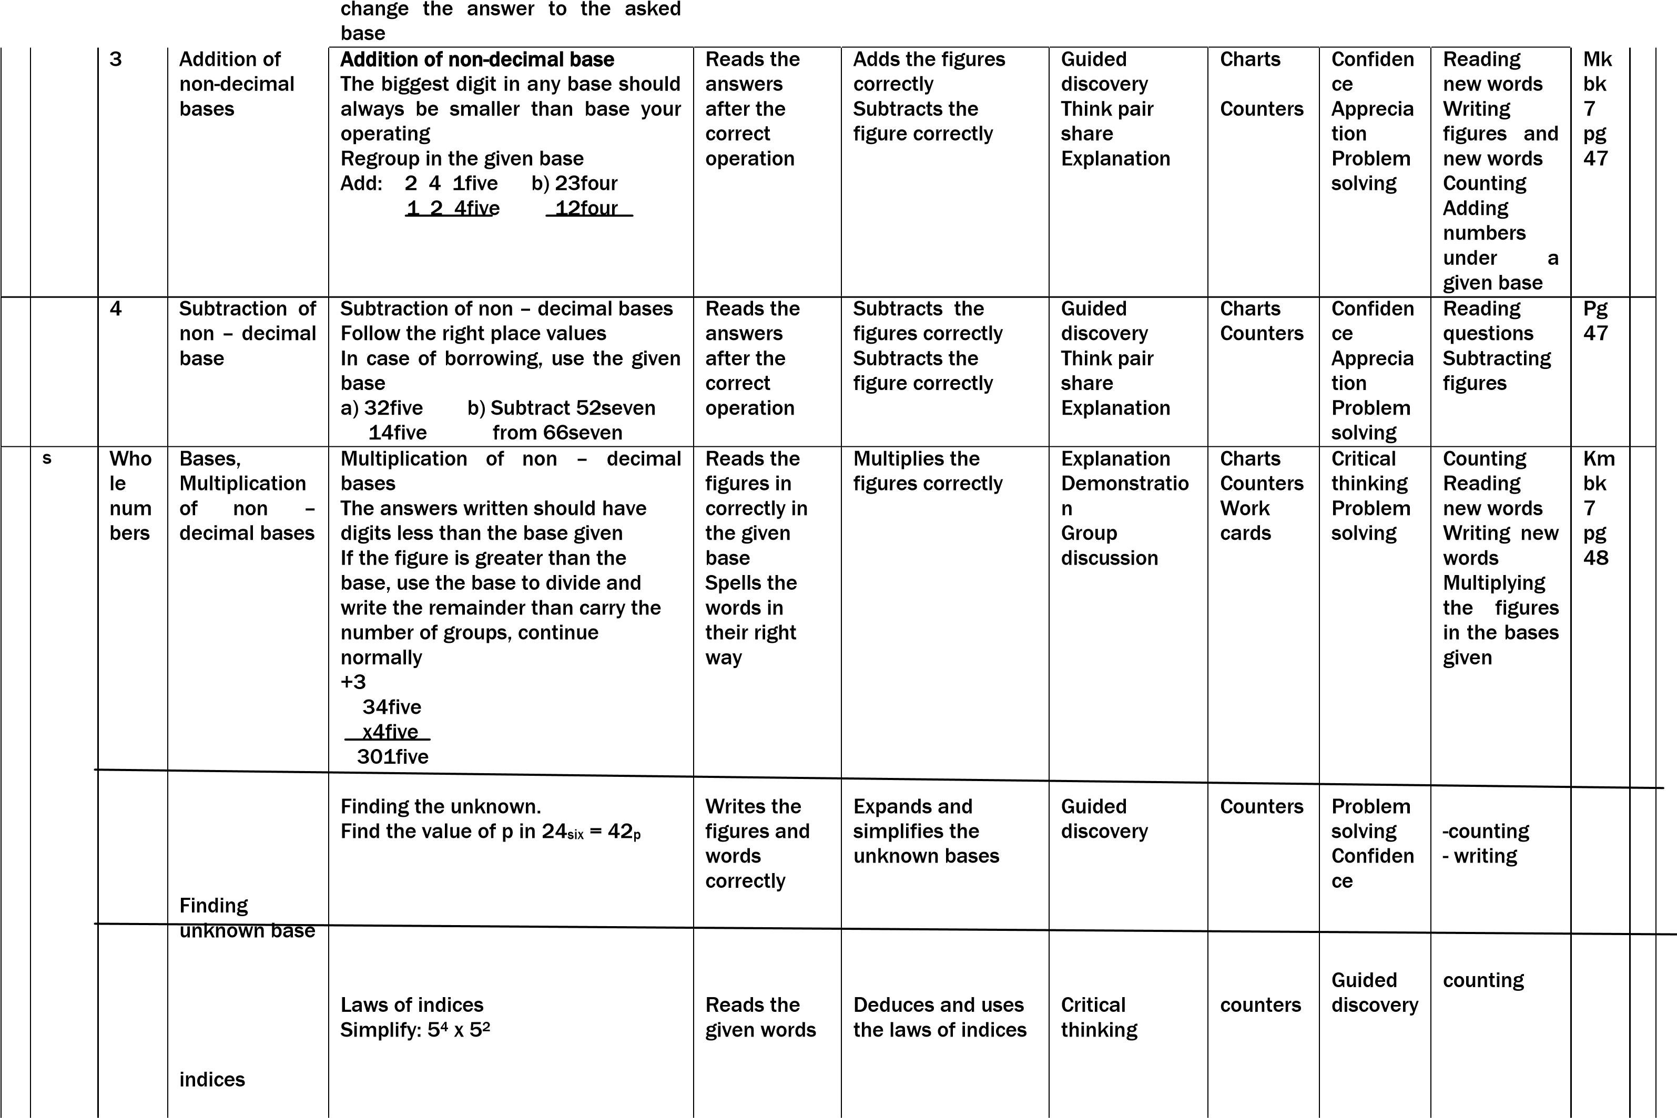12three to base five
2. 26seven to base four Convert to decimal base the finally

|  |  |  |  |  |  |  |  |  |  |  |  |  |  |
| --- | --- | --- | --- | --- | --- | --- | --- | --- | --- | --- | --- | --- | --- |
|  |  |  |  |  |  |  | |  |  |  |  |  |  |
|  |  | OP  E  R  A  T  I  O  N    O  F    N  UMB  E  R  S | Addition of whole number | Addition of large whole numbers up to 7 digits  3058768 (2) 4821481  + 431231 +3149353    3489999 7970834 | Reads the new words | Arranges figures  vertically  Adds the numbers  correctly | | Discussion      Explanation    Question and answer | Chart        Chalk board  illustrati on | Problem solving Effective  commun  ication | Writes an exercise by adding whole numbers    A arranging  digits vertically Adding figures | Mk bk  pg 49 |  |
|  |  | Subtraction of  large numbers. | Subtraction of large numbers a) 3241780 b) 3241784  -1120420 - 34525    21210420 3207259 | Reads the new words  confidently Forms simple structures from the give words | Arranges th correctly Subtracts correctly | e digits figures | Discussion      Explanation    Question and answer | Chart        Chalk board  illustrati on | Interpers onal relation ship | Learners  -Write and exercise by adding whole | Pg 56 |  |
| numbers corr |
|  |
|  |  | Multiplication  of large  numbers | Multiplication by 2 and 3 digit numbers  1) 1432 b) 5640  X 132 x 15  2864 28200  4296 +5640  + 1432 84600  189024 | Pronounces new words  fluently  Writes digits in right place  values | Arranges vertically Multiplies correctly | figures figures | Discussion      Explanation    Question and answer | Chart        Chalk board  illustrati on | Effective  commun  ication Creative thinking | Multiplying numbers  correctly Writing digitsin right places | Mk bk  7p  g 57 |  |
|  |  | 6 | Addition and multiplication | Addition and multiplication on  numbers and division Combined operation  1) 5 + 4 x 3 = 5 + (4 x 3)  = 5 + 12  = 17 | Writes numbers Reads numbers | A learner  -adds numbers as  per BODMAS rule | | Discussion      Explanation    Question and answer | Chart        Chalk board  illustrati on | Creative thinking Interpers onal relations  hip | Adds,Multip  lies and  divides numbers |  |  |
|  |  | 1 |  | Division of whole number by long division 120 6360  1 2 3 4 5 6 7 8 9  M120 , 240,360,450,600,720,840,960,1080  53  120 6360  -600 = 53  360 | A learner -Identifies  the 9 multiples of the divided -Divides  large  numbers by long division. | Learner  -Read words like multiples, long Division and uses them in sentences  correctly | | Discussion      Explanation    Question and answer | Chart        Chalk board  illustrati on | Effective  commun  ication Critical thinking | Dividing the numbers  correctly | MK  MT  C  BK  6  pag e 60 |  |
|  |  | 2 |  | Types of numbers  1.Odd nos 1,3,5,7,9 - - - -  2.Even nos 0,2,4,6,8,10 | A leaner  -Identifies the different | Learner;  -Reads the new words | | Discussion | Chart | Effective commun  ication | Identifying the different types of | -do-  Pa  ge |  |

|  |  |  |  |  |  |  |  |  |  |
| --- | --- | --- | --- | --- | --- | --- | --- | --- | --- |
| 3.Squarenos 1,4,9,16,25,36  4. Cube no,1,8,27,64,125  5.Prime nos 2,3,5,7,11,13  6.composite. 4,6,8,9,10,12,14,15  7.Tangular nosn(n+1)eg | types of numbers. -Members examples of each type of | -Spells words | the | new | Explanation    Question and answer | Chalk board  illustrati on | Creative thinking | numbers Finding the next  number in  the | 57  -  59 |

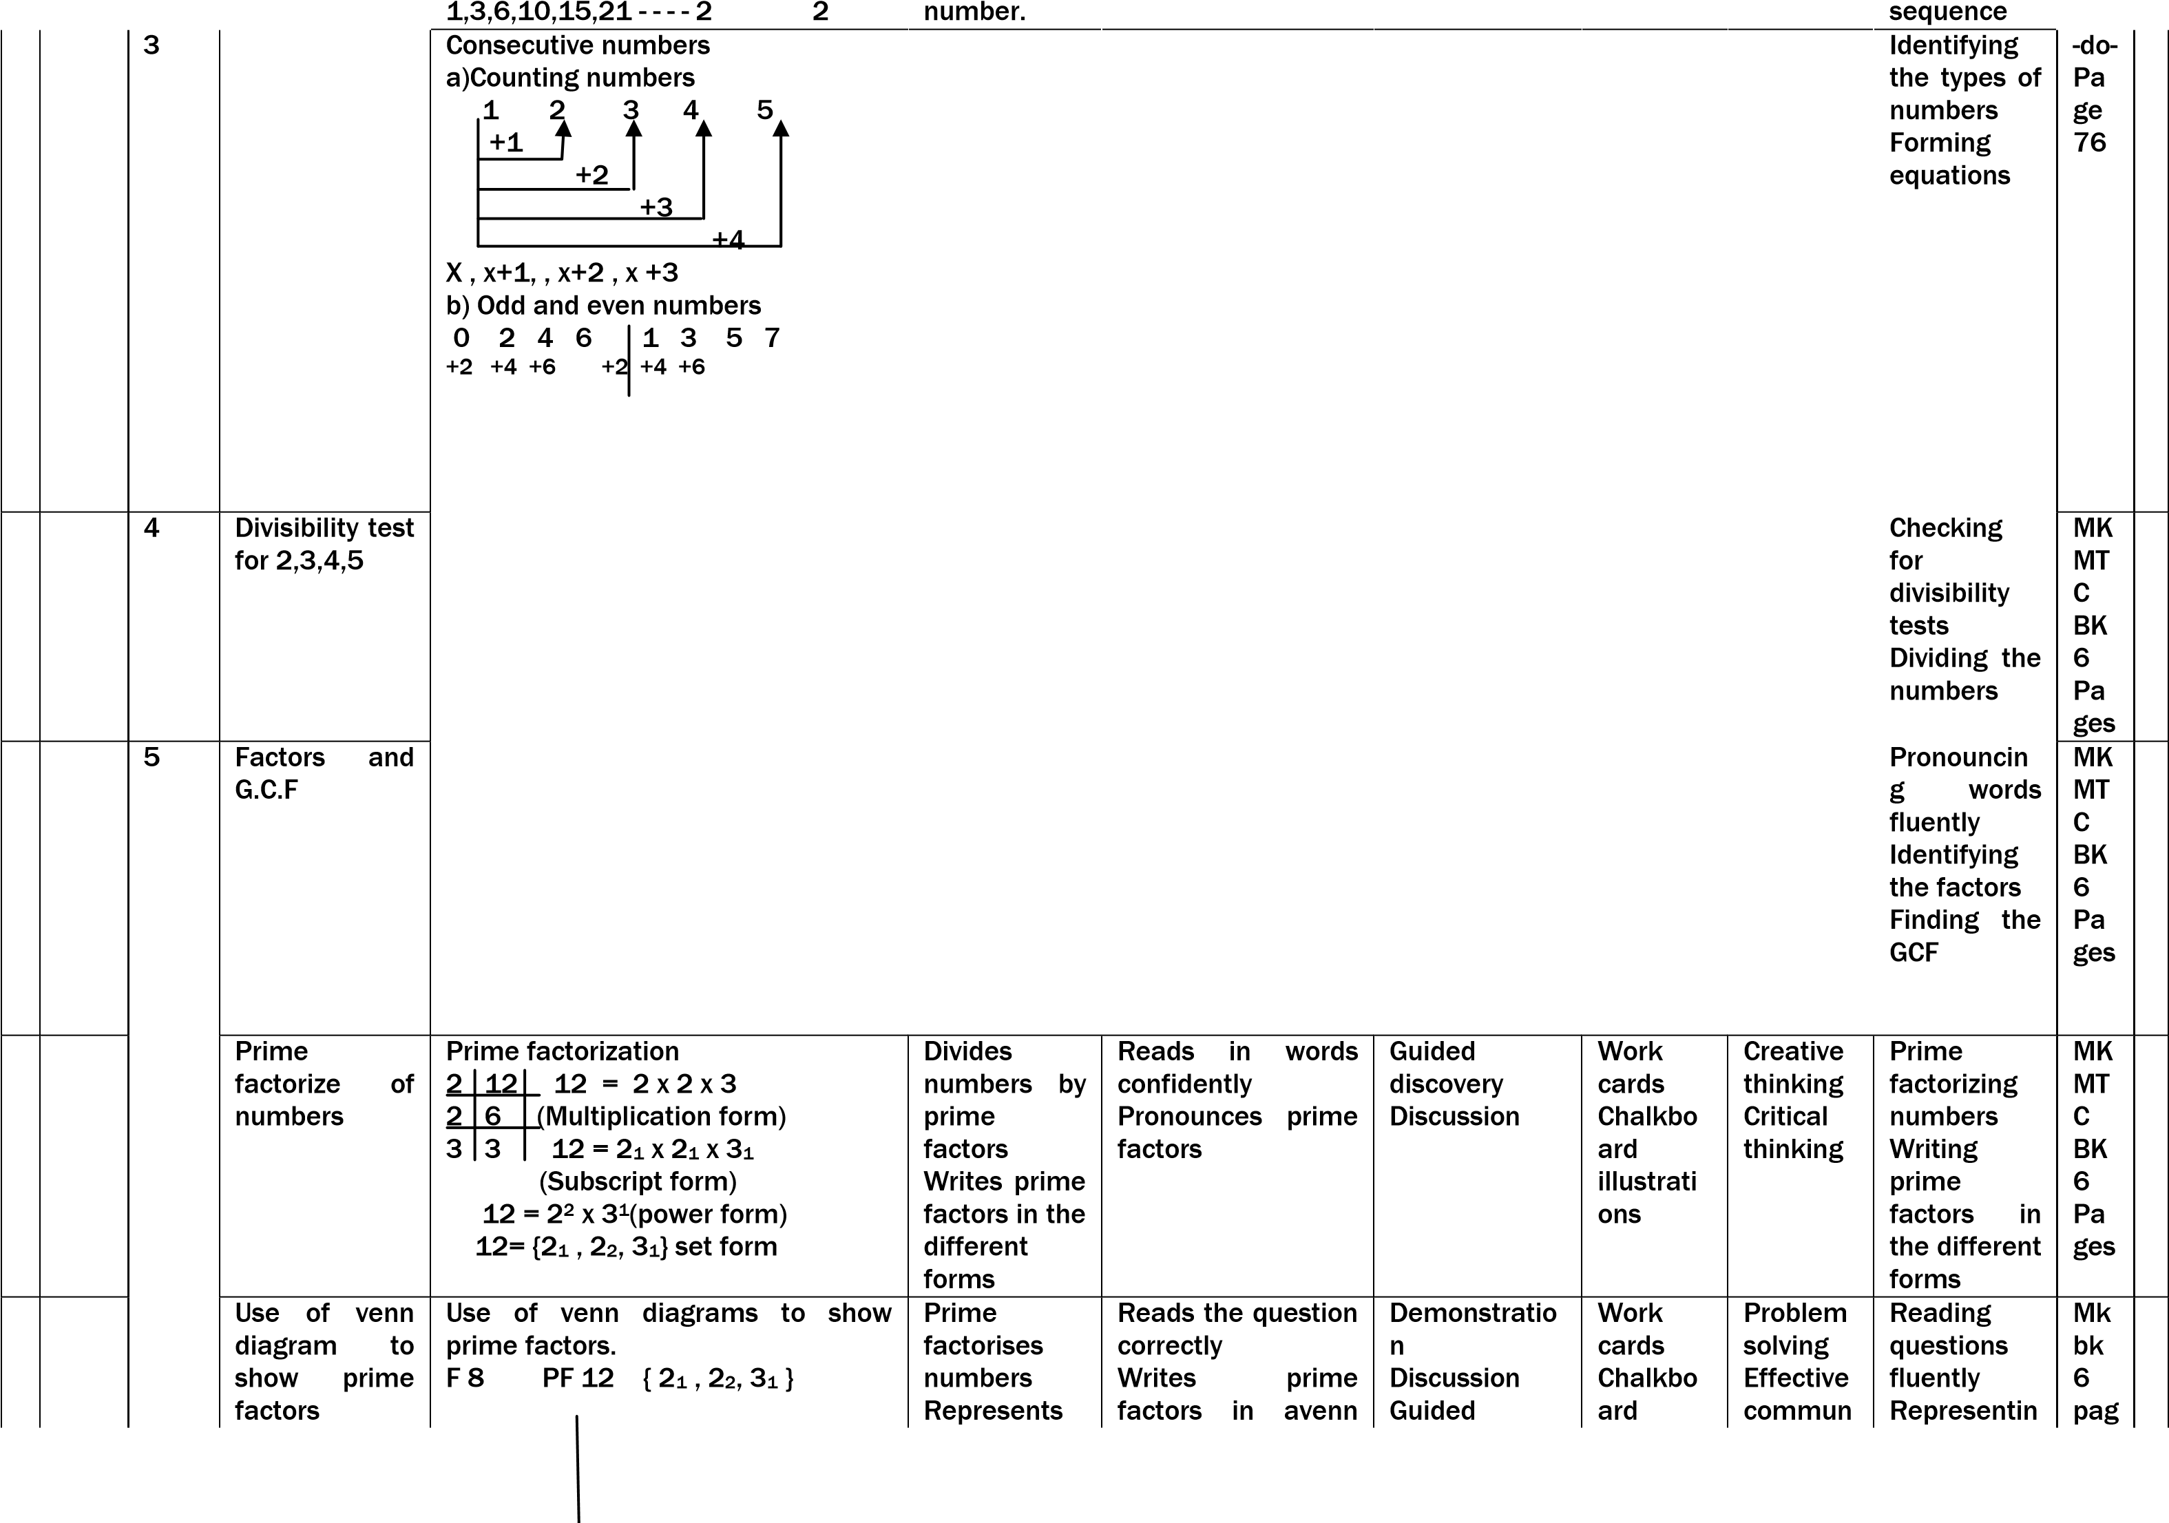

|  |  |  |  |  |  |  |  |  |  |  |  |  |
| --- | --- | --- | --- | --- | --- | --- | --- | --- | --- | --- | --- | --- |
|  |  |  |  |  |  |  |  |  |  |  | e |  |
|  |  |  | Mk bk  6  pag  es |  |
|  |  |  | Mk bk  pg 56 |  |
|  |  | 4 | Application of LCM and GCF | Application oof GCF and LCM 1st number x 2nd number = LCM x GCF of two numbers are 24 and 4. Find the second number given that the first number is 12. | Compares the product of lcm and gcf with give numbers | Pronounces new words | Explanation Guided  discovery | counters | Problem solving Effective  commun  ication fluency | Multiplying and dividing figures  correctly |  |  |
|  |  | Pa  T  T  E  R  N s    a n | Square roots of whole  numbers | Square roots of whole numbers    36     |  |  | | --- | --- | | 2 |  | | 2 |  | | 3 | 9 | | 3 | 3 | |  |  |   36 (2x2) x (3x3)  18 2 x 3  6    1 | Prime  factorizes  the given numbers  Multiplies  the prime factors correctly | Writes the prime  factors correctly | Discussion Demonstratio n  Guided discovery | counters | Problem solving Creative thinking fluency | Prime factorizing numbers  Multiplying prime  factors |  |  |

|  |  |
| --- | --- |
|  |  |
|  |  |

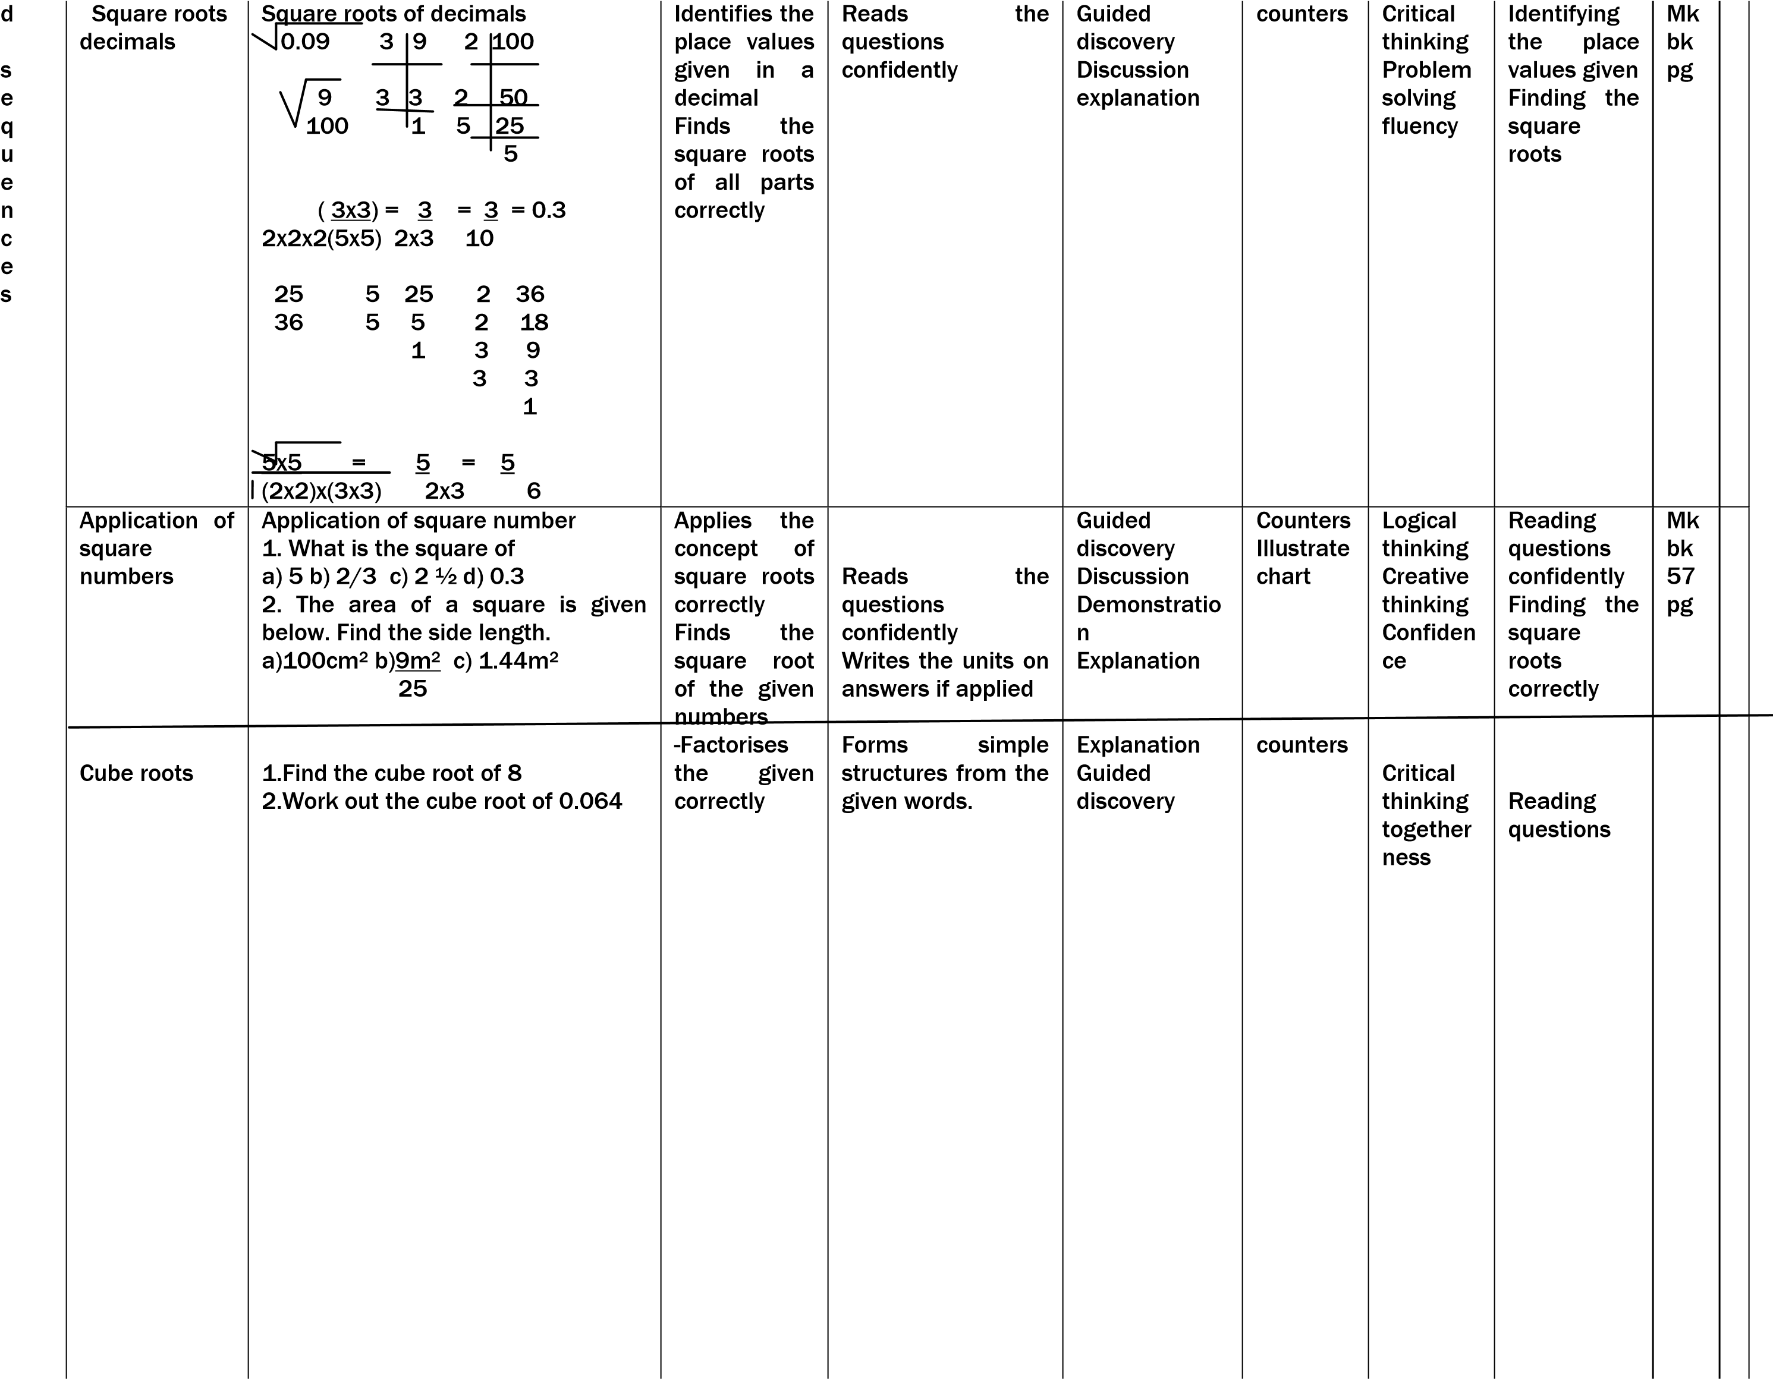

|  |  |  |  |  |  |  |  |  |  |  |  |  |
| --- | --- | --- | --- | --- | --- | --- | --- | --- | --- | --- | --- | --- |
|  |  | Inte gers | The number ordering and  comparing integers | The horizontal and vertical number lines showing integers on the horizontal and vertical number lines.  The vertical          Towards the north positives          Towards the south negatives    The Horizontal    Towards the right positives                      Towards the left negatives  Writes 1 , -1 , 0 , 5 , -4 , -3 and -2 in  ascending order  -4 , -3 , -2 , -1 , 0 , 1 , 5  Use < , > or = to complete below correctly - 6 > 10 | Reads and  tells  meaning of used vocabulary e.g.  horizontal vertical interger | Draws and labels integers on the horizontal and vertical numberline Writes integers in ascending and descending order Compares  intergers using the comparison symbols < , > or = | Guided discovery Guided discussion | Charts showing vertical and horizonta l number  line | Logical flow of ideas | Drawing  Ordering  Comparing | Mk bk  6 pg |  |
|  |  | 6 | Addition of integers using number line and writing addition mathematical statements on a number line | Arrows and direction on a  numberline  Write the integers shown on the numberline below        a = +5 ,b = +5, c = +3 , d = +3, e= -5  Add +2 + -5 using a numberline      +2 +-5 = -3  Writes the mathematical statements shown on the numberline.      Writes the integers shown by a , b write the mathematical statement. | Read the arrows correctly  Reads given integers  correctly | Shows arrows on numberline Writes integers shown by arrows Adds using a number line Writes mathematical statements shown on a number line | Guided discussion Guided discovery | A chart showing arrows on a  number line and addition | Analytica l thinking Effective  commun  ication | Drawing Writing integers |  |  |

|  |  |  |  |  |  |  |  |  |  |  |  |  |
| --- | --- | --- | --- | --- | --- | --- | --- | --- | --- | --- | --- | --- |
|  |  | 1 | Subtraction of integers using a number line and writing  subtraction of mathematical statements shown on number lines | Subtract -3 - +4 using a number line      -3 - +4 = -7    Write the mathematical statement shown on the number line below.    3 - -4 = +7        q  –    p = r | Reads the given integers  correctly  Reads arrows on  the number  line | Subtracts using the number line correctly  Writes subtraction statements shown on the number line correctly | Problem solving Guided discussion | Charts showing | Logical  flow of ideas | Drawing and representin g arrows |  |  |
|  |  | 2 | Multiplication of integers using a number line | Multiplying 2 x 3 using a number  line 2 groups of 3 | Reads given statements correctly | Multiplier integers using a number line correctly | Guided discovery Guided discussion | Charts showing multiplic ation of integers  using a  number  line | Critical thinking | Drawing Multiplying |  |  |
|  |  | 3 | Addition and subtraction of integers without a number line | Multiplier rules of signs   * x + = - * x - = +   + x - = - + x + = +  Work out: -6—9  -6-(-9) -6 + 9  9 – 6  = 3  Work out: -5 + -2  -5 + (-2)  -5 – 2  -7 | Reads  multipliers rules of signs Reads given integers correctly | Adds and subtracts given integers correctly | Problem solving  Group work | A chart showing addition and  subtracti  on of  integers | Creative thinking Logical reasonin  g  Logical  flow of ideas | Adding and subtracting integers |  |  |
|  |  | 4 | Multiplication and division of integers | Work out:  -6 x -3  = +18  Divide  -16 ÷ +8  = -2 | Reads given statements correctly | Multipliers and divides integers  without a number line correctly | Guided discovery Guided discussion | Chart showing multiplic ation  and  division of integers | Critical thinking Logical  flow of ideas | Multiplying Dividing |  |  |

|  |  |  |  |  |  |  |  |  |  |  |  |  |
| --- | --- | --- | --- | --- | --- | --- | --- | --- | --- | --- | --- | --- |
|  |  | 5 | Application of integers | The temporary was 20oF and dropped by 23oF. Find the new  temperature  20oF – 23oF  -3oF | Reads given information correctly | Computes relevant information and answers correctly | Problem solving Guided discussion | Board  illustrati on | Creative thinking Logical  reasonin g | Reading  Working out |  |  |
|  |  |  |  |  | do | do | Explanation  demonstratio n | Illustrate d chart | Critical  thinking | Identifying  the axes  correctly | Mk bk  pg 59 |  |
|  |  | 1 | Potting Co – ordinates in a graph | Plotting co – ordinates in the graph.  Eg A (1,1) B (2, -1) C (-2, -1) D(1,3)  Y   |  |  |  |  |  |  |  |  |  |  | | --- | --- | --- | --- | --- | --- | --- | --- | --- | --- | |  |  |  |  | 4 |  |  |  |  |  | |  |  |  |  | 3 |  |  |  |  |  | |  |  |  |  | 2 |  |  |  |  |  | |  |  |  |  | 1 |  |  |  |  |  | | -4 | -3 | -2 | -1 | 0 | 1 | 2 | 3 | 4 | 5 | |  |  |  |  | -  1 |  |  |  |  |  | |  |  |  |  | -  2 |  |  |  |  |  | |  |  |  |  | -  3 |  |  |  |  |  | |  |  |  |  | -  4 |  |  |  |  |  | | _Draws a  graph  -Plot co –  ordinates  -Identifies  the co –  ordinates correctly |  |  | Illustrate chart Chalkbo ard  illustrati on |  |  | mk  bk  pg  13  6 |  |

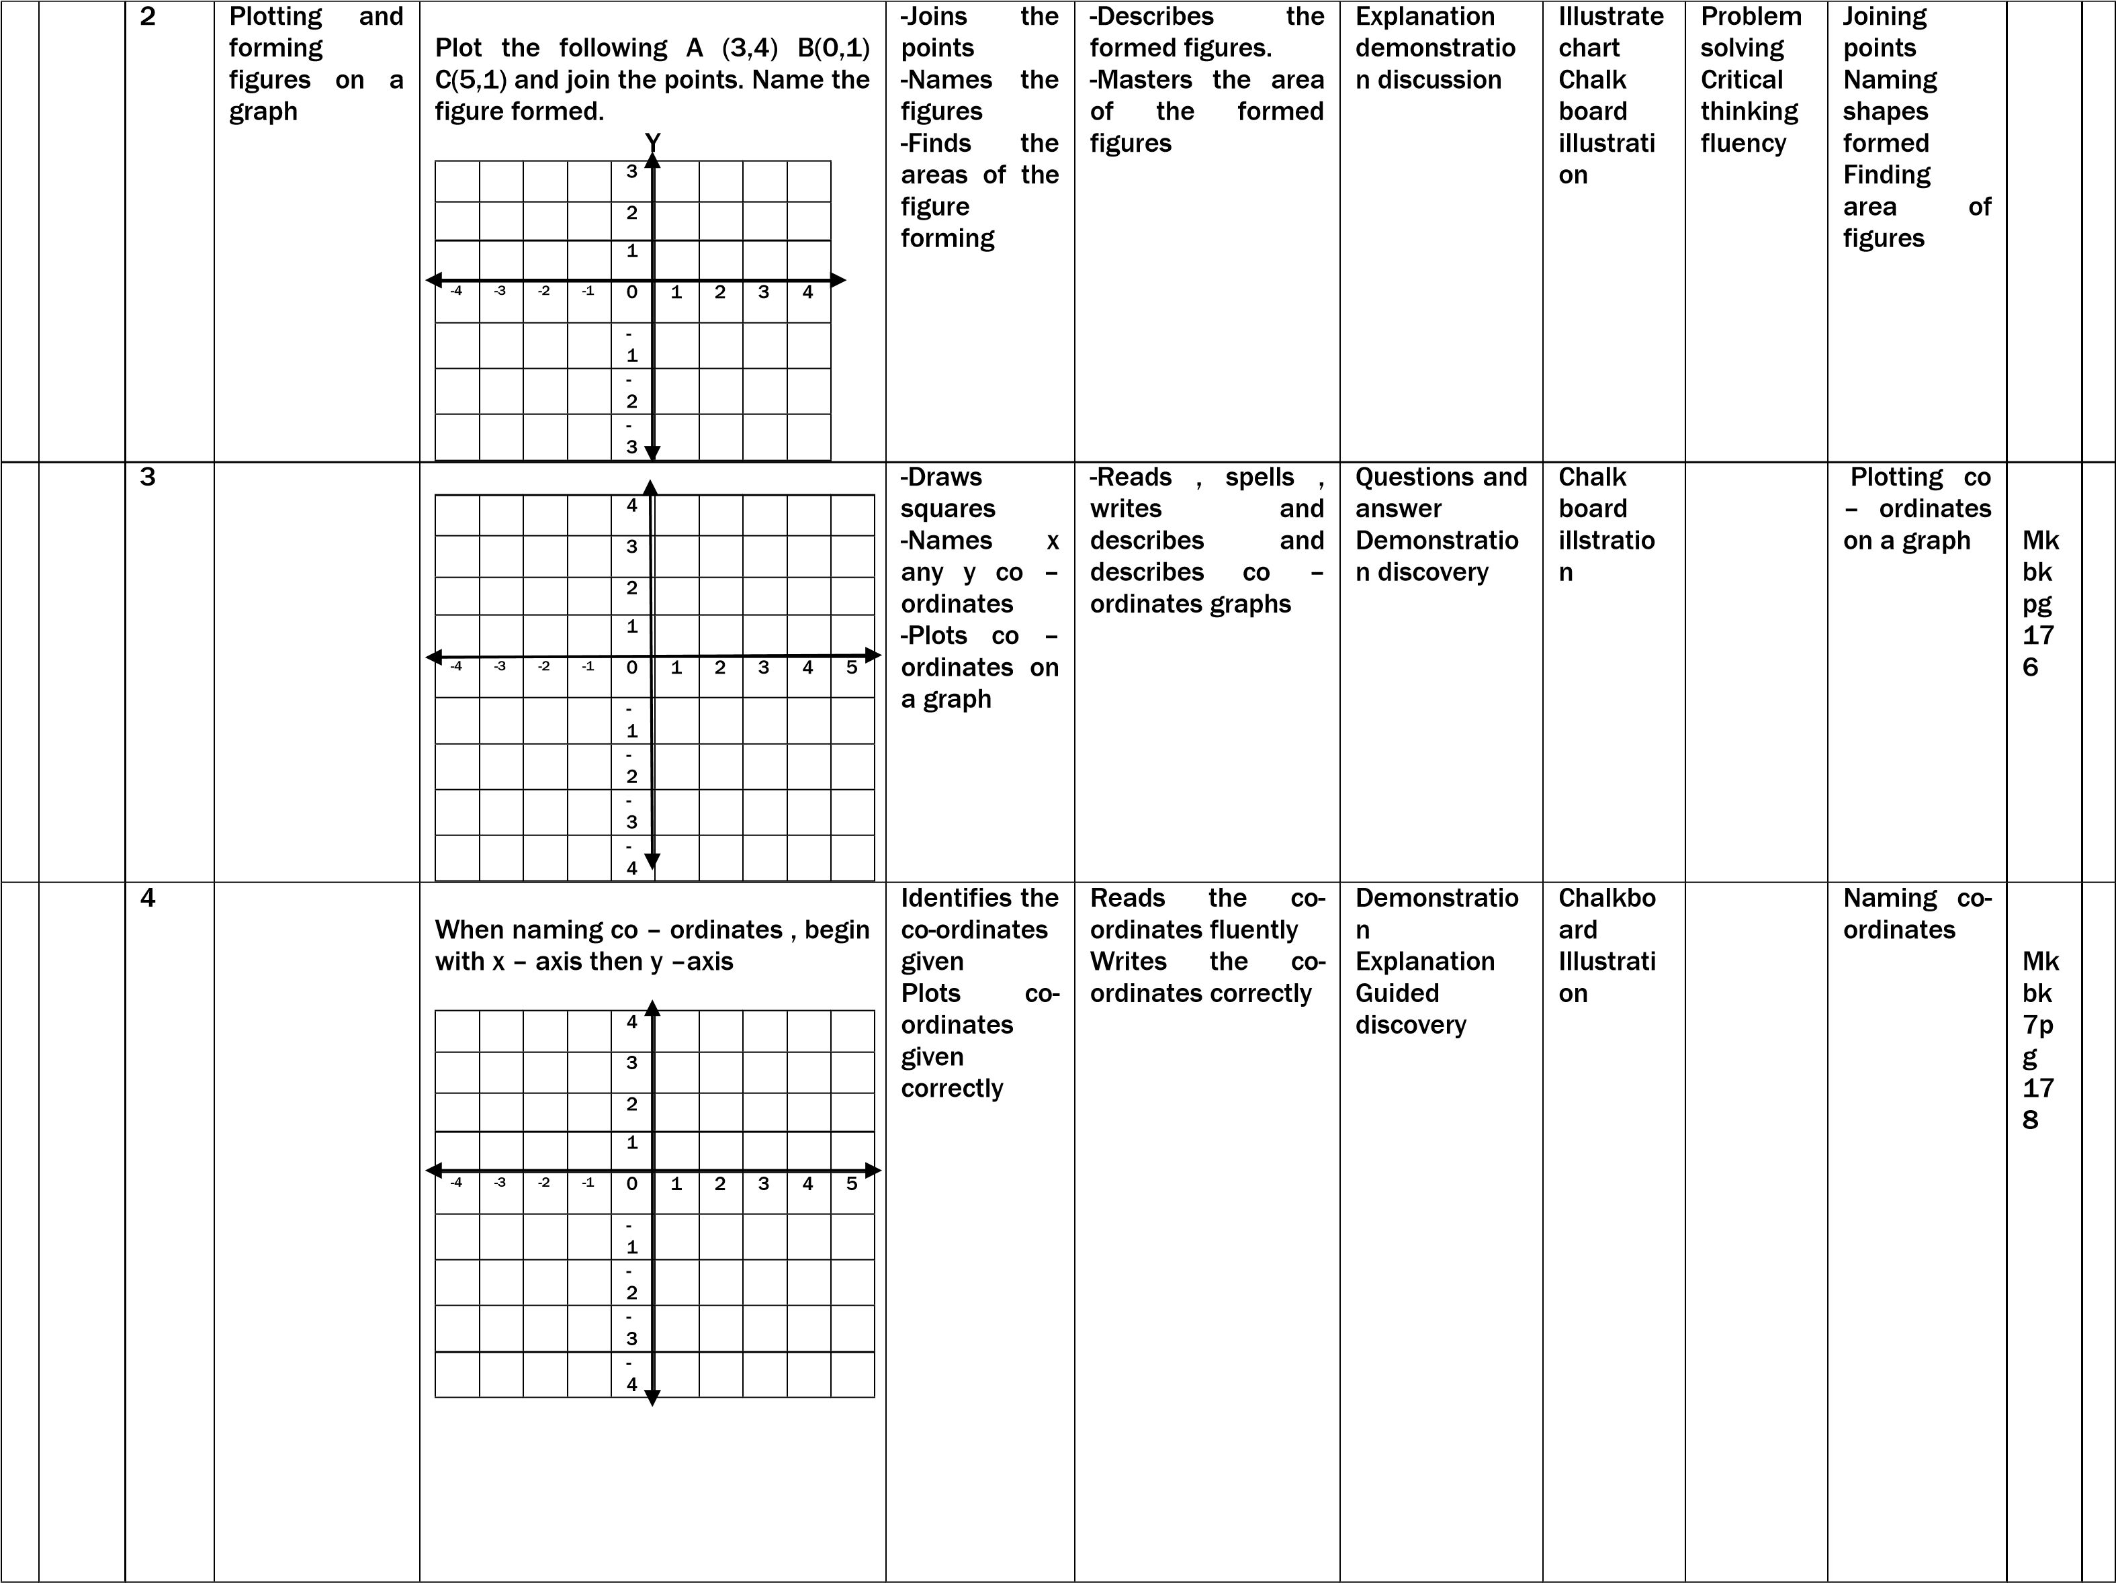

|  |  |  |  |  |  |  |  |  |  |  |  |  |
| --- | --- | --- | --- | --- | --- | --- | --- | --- | --- | --- | --- | --- |
|  |  | Finit e  syst em | Addition of numbers in  finite system | Counting numbers in finite system; Finite 4: {0 , 1 , 2 , 3} four digits used  Finite 5: {0,1,2,3,4} five digits used Addition in finite system.  Consider the finite given  Sum should be less than one given finite  Incase of equality or above the finite, form groups of the finite and write the reminder as the answer 3 + 4 = ___(finite 7) use a dial | Describes the digits under the given finite | Counts the digits in the given finite Adds the figures in the given finite | Think pair  share Group discussion | Charts | Critical thinking Effective  commun  ication | Describing digits in given finite Adding the figures  given | Mk bk 7 pg  17  8 |  |
|  |  | 6 | Subtraction on numbers in finite system | Subtraction of numbers in finite system  Subtract 3 – 4 = _____(finite 7)  (3+7) – 4 =  10 – 4 = 6  :. 3 – 4 = 6 (finite 7)  Variety of examples to be used  Use of a dial | Reads the words and figures confidently | Identifies the finites used Subtracts the figure used correctly in consideration of the finite | Think pair  share Group discussion | Charts | Critical thinking Effective  commun  ication | Reading the new words  given Identifying the finite Subtracting the figures given |  |  |
|  |  | 1 | Mixed  operation in finite system | Addition and subtraction in finite  Workout: 23 – 3 + 2 = ____(finite 7)  Simplify: 2 + 1 – 3 = ____(finite 5)  Workout: 5 – 7 + 2 = ____(finite 5)  Application of BODMAS rule is used Use of a dial | Describes the integers given correctly | Uses the rule of  BODMAS correctly  to solve | Demonstratio n  Group discussion | Charts Work cards | Confiden ce  Problem solving | Writing new words Counting numbers or values  Using the rule of BODMAS  correctly Multiplying  the given values  under the  stated finite | Mk bk 6 pg 50 |  |
|  |  | 2 | Multiplication of numbers in finite system | Multiplication in finite system  Multiply: 2 x 3 = _____(finite 5)  2 x 3 = 6  6 ÷ 5 = 1r1  2 x 3 = 1 (finite 5)  Use of a dial | Describes the given finite | Multiplies the figure in respect to the finite given | Guided discovery Group discussion | Chalk boar  illustrati on | Problem solving creative thinking | Mk bk 6 pg 50 |  |
|  |  | 3 | Division | Division in finite system  Work out:7 ÷ 8 = ____(finite 4)  (7 + 4) = 11  11 ÷ 8 = 1 r 3  7 ÷ 8 = 3 (finite 4) | Reads the words confidently | Divides numbers correctly | Explanation | Chalkbo ard illustrati oin | Creative thinking Problem solving  confeden ce | Dividing numbers  under a  stated finite | Pg 48 |  |
|  |  | 4 | Unknown  value in finite system | Finding unknown value in finite  system  Solve for x  3x = 4 (finite 7)  4 + 7 = 11 (finite 7)  11 + 7 = 18 (finite7)  3x/3 = 18/3  X = 6 (finite 7) | Describes the given  finite  Pronounces words correctly | Carries out basic operations Solves the statement  according to the  finite | Explanation Demonstratio n  Group work | Charts Chalkbo ard illustrati on | Problem solving Critical thinking | Counting values of numbers Reading new words  give fluently | Pg 49 |  |

|  |  |  |  |  |  |  |  |  |  |  |  |  |
| --- | --- | --- | --- | --- | --- | --- | --- | --- | --- | --- | --- | --- |
|  |  |  |  |  |  |  |  |  |  |  |  |  |
|  |  | 5 | Finite system Word problem | Application of finite system  Application of clock arithmetic of mode 7. Applied in counting days of the week   1. = Sunday 4 = Thursday 2. = Monday 5 = Friday 3. = Tuesday 6 = Saturday 4. = Wednesday   Application of finite 12. Applied when counting months of the year. Jan Feb Mar Apr May Jun Jul  1 2 3 4 5 6 7  Aug Sept Oct Nov Dec  8 9 10 11 12 | Reads the words and structure  fluently  Describes the mode used | Carries the basic operation correctly Solves the word problem involving the finite given | Guided discovery Group discussion Think pair share | Charts  Counter Chalkbo ard illustrati ons | Confiden ce Fluency Problem solving  Critical  Thinking | Reading new words Writing new words Counting values Solving problem involving  finite | Mk bk 6 pg 56 |  |
|  |  |  | TERM TWO 2017 | | | | | | | | |  |
|  |  | ALG  EBR  A | Collecting like terms | Example;  Simplify: r + r + n  3n  Example  Simplify: 3x + 6  + - x -2y  3x – x + 6y – 2y  2x + 4y | Learners Define like terms  Collect like terms | Learners;  Need write, spell new words like collect, like, term | Problem solving Guided discovery | Critical thinking Creative thinking Effective  commun  ication | Real objects like leaves, stones, bottle tops | Learner sort objects and collect like terms |  |  |
|  |  |  | Substitution | Example given that  P = -6  Find P + 2  -6 + 2  -4 | Learner; Substitute correctly  Work out member correctly | Learners read; write, spell words like substitute, replace | Guided discussion Explanation  Discussion | Effective  commun  ication Problem solving | Real objects like leaves, stones, bottle tops | Learner substitute |  |  |
|  |  |  | Removing brackets | Example simplify  3(b + 4)  X  3 x 6 + 4 x 3  3b + 12 | Learner; Remove  brackets Simplify algebraic | Learners read, write, spell new words brackets, simplify | Guided discovery Explanation  Discussion Brain storming | Problem solving Critical thinking | Chalkbo ard illustrati on | Learners remove bracket simplify |  |  |
|  |  |  | More about removing brackets | Example  Simplify  3(x + 3) – 2(x – 1)  3x + 9 – 2x +2  3x – 2x + 9 + 2  X + 11 | Learners;  Remove bracket Simplify algebraics | Learners read, write, spell new words brackets, simplify | Brain storming Guided discussion Guided discovery | Creative thinking Critical thinking | Chalkbo ard  illustrati on | Learner remove bracket and simplify |  |  |

|  |  |  |  |  |  |  |  |  |  |  |  |  |
| --- | --- | --- | --- | --- | --- | --- | --- | --- | --- | --- | --- | --- |
|  |  |  | Indices | Simplify m3 x m2  Mxmxmxmxm – m5  Or  M(2+2) = m5 Example  Sin/Simplify: P5 ÷ P3 | Learners; State laws of indices Multiply power of the same base | Learners read, spell, pronounce indices, index exponent, base, product | Problem solving Brain storming  Explanation Guided discussion | Critical thinking Analytica l thinking | Chalkbo ard  illustrati  on  A chart showing indices | Simplify indices |  |  |
|  |  |  | Solving simple equation | Example;  Solve x + 3 = 9  X + 3 – 3 = 9 – 3  X = 6 | Learner; Solve simple equations Collect like terms  correctly | Learners read, spell, pronounces equations, like terms | Problem solving Guided discussion Explanation | Effective  commun  ication Creative thinking | Chalkbo ard illustrati on | Solving equation |  |  |
|  |  |  | Forming and  solving equation | Example  Moses has 8 more cows than Kato If both have 16 cows. How many cows does Moses have?  Let Kato’s no. of cows be y | Learners will Form equations Solve equations | Learners spell, pronounce, equation solve | Problem solving Guided discussion Explanation | Effective  commun  ication Creative thinking | Chalkbo ard  illustrati on | Learners practice forming solving equation |  |  |
|  |  |  | Solving fraction equation | Example  Solve  2p/4 + 5 = 17  2p/4 = +5 – 5 = 17- 5  2p/2 = 12.4/2  P = 6 x 4  P = 24 | Learners; Identify equation Solve equation with fractions | Learners read, spell, pronounce, new words, fraction, equations. | Brain storming Problem solving Discussion | Critical thinking creative thinking | Learners practice solving  equation  s | A chart  showing solving fraction equation |  |  |
|  |  |  | More about forming and solving equations | Example Okello is 8 years older than John. If their total age is 20 years, how old is each person? Let  John’s age be k  K+ k + 8 = 20  2k + 8 – 8 = 20 -8  2k/2 = 12/2  Okullo  K + 8  6 + 8  144years  John  6 years | Learners;  Read and  interpret questions Solve equations | Learners read, spell, pronounce new words equation | Guided discovery  Explanation Brain storming | Critical thinking Effective commun  ication | Learners practice Solving  equation  s | A chart  showing solving equations |  |  |
|  |  |  | Solving equation involving brackets | Solve:  3(y +4) = 12  3y + 12 = 21  3y + 12 – 12  = 21 – 12  3x/3 = 9/3  X = 3 | Learners;  Remove  brackets Solve equations | Learners read, spell, pronounce words equation, brackets etc | Explanation Guided discovery Guided discussion | Critical thinking Effective  commun  ication | Chalkbo ard illustrati on | Learners practice solving equation |  |  |
|  |  |  | More about  equation | Solve:  3(y + 4) = 12  3y + 12 = 21  3y + 12 – 12  = 21 – 12  3y/3 = 9/3  Y = 3 | Learner; Collects like terms  Solves for the unknown | Learners read, spell, unknown, equation | Explanation Guided discovery Guided discussion | Critical thinking Effective  commun  ication | Chalkbo ard  illustrati on | Learners practice solving equation |  |  |
|  |  |  | Application of algebra | The length of a rectangle is twice its width and its perimeter is 24cm  Let the width be x  2x  Calculate the actual length and width  2(L+W) = P  2(zx + x) = 24  4x + 2x = 24  6x/6 = 24c/6  Length  2x = 2 x 4c = 8c  Width  X = 4 | Learners; Identify equations Form equations Solve equations | Learners read,  spell, equations, unknown |  |  |  |  |  |  |
|  |  | Alge bra (ine qual  ity) | Solve and form (write) solution sets | Give the solution set for: x < 5  X = {1 , 2 , 3 , 4}  X = {4,3,2,1} | Learners; Solve inequalities Write solution sets | Learners read, write, spell new words like inequalities, solve, equations | Guided discussion Problem solving Guided discovery | Creative thinking Analytica l thinking Effective  commun  ication | Chalkbo ard  illustrati on | Learners practice solving and writing solution set |  |  |